Day 03

1. For the given JSON iterate over all for loops (for, for in, for of, forEach)

Ans

let data = require("./q1_json_data");

for(let i=0;i<data.length;i++){

    console.log(data[i].name);

}

console.log(`

-----------------------------------------------------

-----------------------------------------------------`);

for(let i in data){

    console.log(data[i].name);

}

console.log(`

-----------------------------------------------------

-----------------------------------------------------`);

for(let i of data){

    console.log(i.name);

}

console.log(`

-----------------------------------------------------

-----------------------------------------------------`);

data.forEach((i) => {

    console.log(i.name);

})

The JSON data passed for question1 is given in the Github repo as a separate JS file **(q1_json_data.js) inside JS_JSON_Files** and has been exported because it is too big to be included here.

I have iterated through the JSON data and printed only the country names as the question only asked about iteration.

#OUTPUT

The screenshot only contains part of the output.

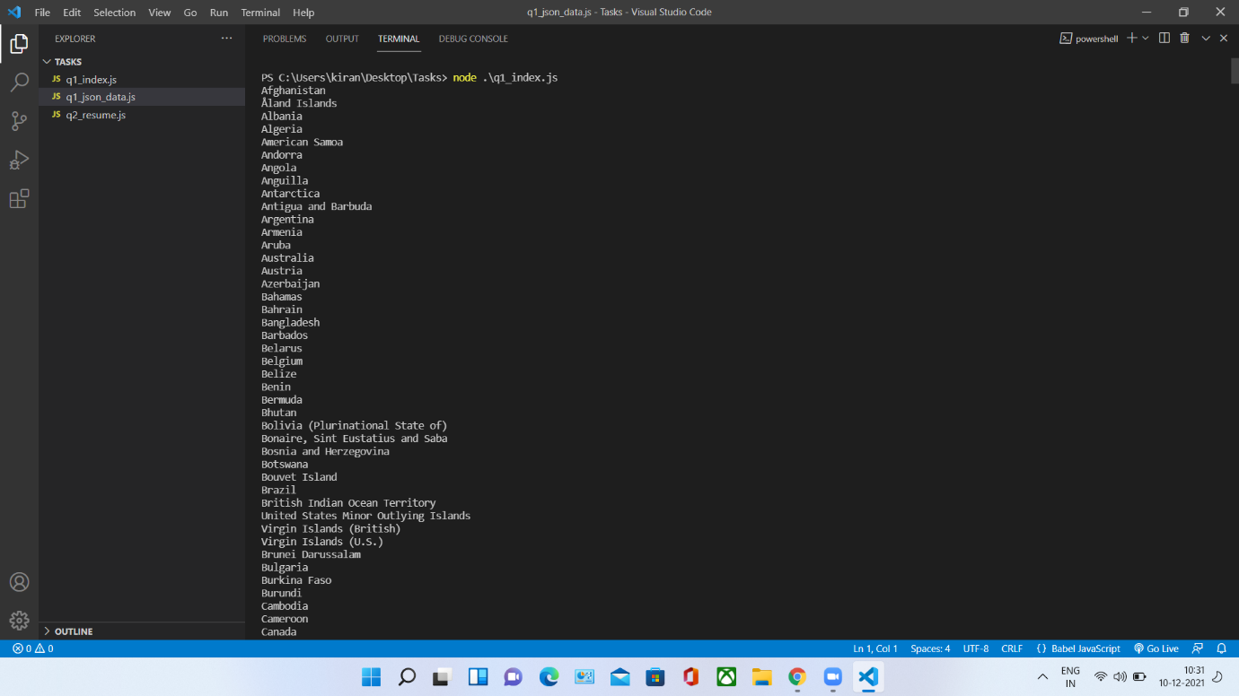

1. Create your own resume data in JSON format

Ans

let resume = {

    "personalInfo": {

        "fullName": "Kiran Baby",

        "emailID": "kiranbaby256@gmail.com",

        "github": "https://github.com/kiranbaby14",

        "linkedin": "https://www.linkedin.com/in/kiranbaby14/",

        "phoneNumber": "7510207694",

    },

    "qualification": {

        "degree": "B_Tech",

        "score": "8.09 CGPA",

        "university": "APJ Abdul Kalam University",

        "branch": "CSE"

    },

    "additionalQualification":{

        "X": "8.2 CGPA",

        "XII": "8.2 CGPA"

    },

    "pgmLanguages": ["Javascript", "Python", "C", "C#"],

    "techStacks": ["MERN", "Django"],

    "projects": ["Hyperface implemented Multiplayer TPS game", "auto webpage creator", "Ninjesk-Game using Unity"],

    "awards": ["Game Begetter", "CSI-Inapp"],

    "tools": ["VScode", "Pycharm", "Git", "Github", "Unity", "AndroidStudio"],

    "languages": ["Malayalam", "English", "Hindi"],

    "hobbies": ["Music", "COding", "Football", "Cricket", "Video Games"],

    "strengths": ["Dedication", "Hardworking", "Leadership"]

}

1. Read about the difference between window, screen and document in javascript

Ans

* The window object is supported by all browsers. It represents the browser's window. All global JavaScript objects, functions, and variables automatically become members of the window object.
* The window object also has a screen object with properties describing the physical display. The portion of a screen displaying the rendered document is the viewport in JavaScript.
* Document is the main object of the potentially visible document object model/DOM. Each window object has a document object to be rendered.

1. Codekata practice